Q1 | A B C D E F
Q2 | A B C D E F
Q3 | A B C D E F
Q4 | A B C D E F
Q5 | A B C D E F
Q6 | A B C D E F
Q7 | A B C D E F
Q8 | A B C D E F
Q9 | A B C D E F
Q10 | A B C D E F
Q11 | A B C D E F
Q12 | A B C D E F
Q13 | A B C D E F
Q14 | A B C D E F

1. According to Circuit Diagram 1, what does E represent in the circuit diagram?
A. A 5 Ohm variable resistor
B. A 5 Amp ammeter
C. A 5 Volt battery
D. A 5 Ohm light bulb
E. A 5 Ohm resistor
F. A fuse

2. What does this circuit diagram show?
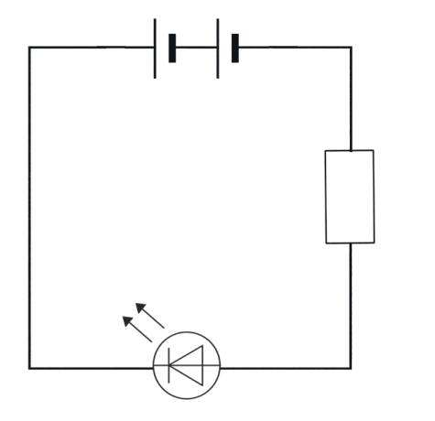
A. It shows a two-cell battery, with a variable resistor, and an LED connected in series.
B. It shows a two-cell battery, with a fixed resistor, and an LED connected in series.
C. It shows a two-cell battery, with a diode, and an LED connected in series.
D. It shows a three-cell battery, with a fixed resistor, and an LED connected in series.
E. It shows a two-cell battery, with a fixed resistor, and an LED connected in parallel.
F. It shows a two-cell battery, with a fixed resistor, and a light bulb connected in series.

3. According to Circuit Diagram 1, what does B represent in the circuit diagram?
A. Negative terminal
B. Positive terminal
C. Fuse
D. Battery
E. Ammeter
F. Voltmeter

4. What does this circuit diagram show?
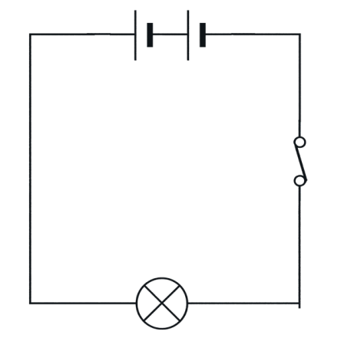
A. It shows a two-cell battery, with a closed switch and a fixed resistor connected in series.
B. It shows a two-cell battery, with a closed switch and a light bulb connected in series.
C. It shows a two-cell battery, with an open switch and a light bulb connected in series.
D. It shows a two-cell battery, with a fuse and a light bulb connected in series.
E. It shows a one-cell battery, with a closed switch and a light bulb connected in series.
F. It shows a two-cell battery, with a closed switch and a light bulb connected in parallel.

5. What does this circuit diagram show?
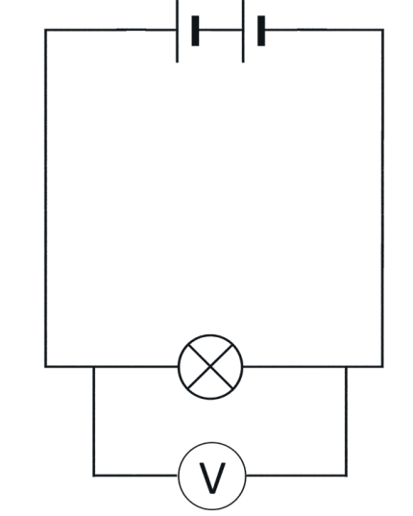
A. It shows a two-cell battery, with a lamp in series, and a voltmeter in parallel measuring the voltage of the lamp.
B. It shows a one-cell battery, with a lamp in series, and a voltmeter in parallel.
C. It shows a two-cell battery, with a lamp in series, and an ammeter in series.
D. It shows a two-cell battery, with a lamp in series, and a voltmeter in series.
E. It shows a two-cell battery, with a lamp in series, and an ohmmeter in parallel.
F. It shows a two-cell battery, with a resistor in series, and a voltmeter in parallel.

6. What does this circuit diagram show?
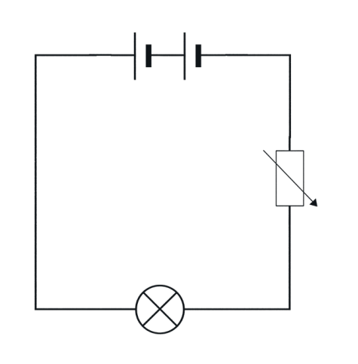
A. It shows a two-cell battery, with a thermistor and a bulb.
B. It shows a two-cell battery, with a light-dependent resistor (LDR) and a bulb.
C. It shows a two-cell battery, with a fixed resistor and a bulb.
D. It shows a two-cell battery, with a variable resistor and a bulb.
E. It shows a one-cell battery, with a variable resistor and a bulb.
F. It shows a two-cell battery, with a potentiometer and a motor.

7. According to Circuit Diagram 1, what does D represent in the circuit diagram?
A. A resistor
B. A light bulb
C. A diode
D. A capacitor
E. A switch
F. A motor

8. What does this circuit diagram show?
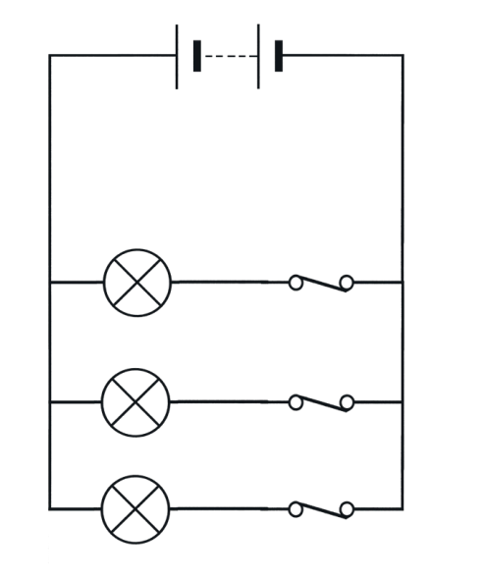
A. It shows a two-cell battery, and three resistors all in parallel with a closed switch for each resistor.
B. It shows a two-cell battery, and three bulbs all in parallel with one master switch.
C. It shows a two-cell battery, and three bulbs all in parallel with a closed switch for each bulb.
D. It shows a two-cell battery, and three bulbs all in series with a closed switch for each bulb.
E. It shows a two-cell battery, and two bulbs all in parallel with a closed switch for each bulb.
F. It shows a three-cell battery, and three bulbs all in parallel with a closed switch for each bulb.

9. What does this circuit diagram show?
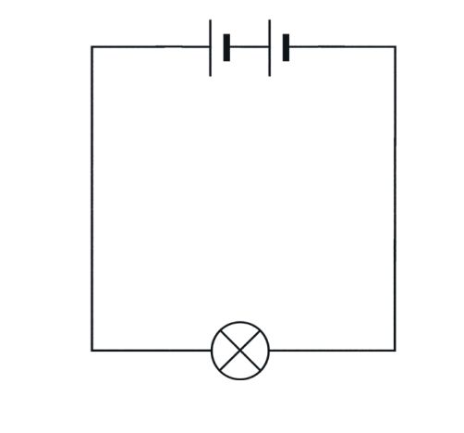
A. It shows a two-cell battery with an LED connected in series.
B. It shows a two-cell battery with a light bulb connected in series.
C. It shows a three-cell battery with a light bulb connected in series.
D. It shows a one-cell battery with a light bulb connected in series.
E. It shows a two-cell battery with a fixed resistor connected in series.
F. It shows a two-cell battery with a light bulb connected in parallel.

10. The following 5 questions refer to Circuit Diagram 1, what does A represent in the circuit diagram?
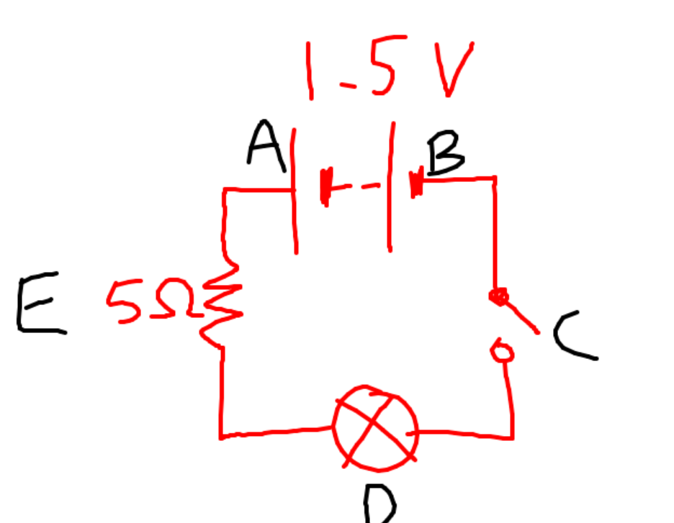
A. A 5 Ohm resistor
B. A closed switch
C. Negative terminal
D. Positive terminal
E. An open switch
F. A light bulb

11. What does this circuit diagram show?
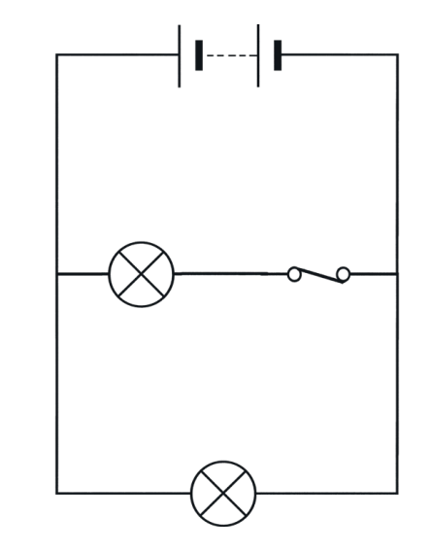
A. It shows a two-cell battery, with two lamps connected in parallel, and one open switch in the main branch.
B. It shows a two cell battery, with two lamps connected in parallel, and one closed switch in the first path, which can switch one lamp off.
C. It shows a two-cell battery, with two lamps connected in parallel, and a switch for each lamp.
D. It shows a two-cell battery, with one lamp and one motor connected in parallel.
E. It shows a three-cell battery, with two lamps connected in parallel, and one closed switch.
F. It shows a two-cell battery, with two lamps connected in series, and one closed switch.

12. What is wrong with this circuit diagram?
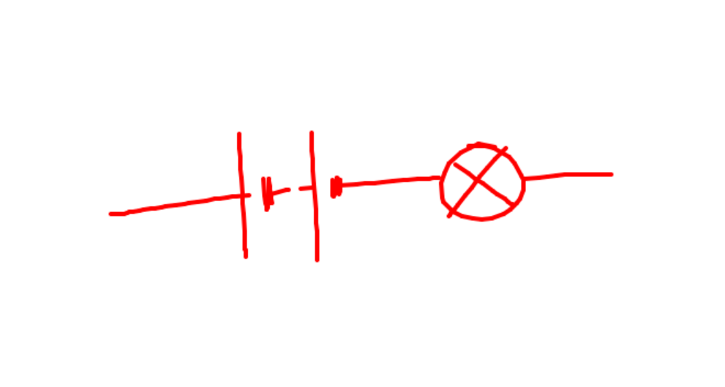
A. The battery is backwards.
B. The switch is in the wrong position.
C. It is not connected, so electricity won't flow.
D. The bulb is broken.
E. There is a short circuit.
F. The voltage is too high for the components.

13. What does this circuit diagram show?
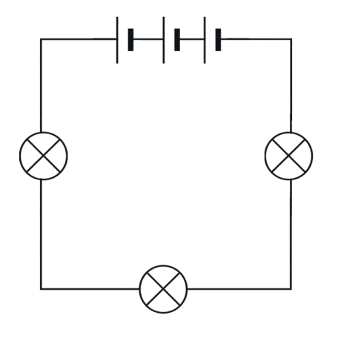
A. It shows a three-cell battery, with three light bulbs connected in series.
B. It shows a three-cell battery, with three light bulbs connected in parallel.
C. It shows a single-cell battery, with three light bulbs connected in series.
D. It shows a two-cell battery, with three light bulbs connected in series.
E. It shows a three-cell battery, with three fixed resistors connected in series.
F. It shows a three-cell battery, with two light bulbs connected in series.

14. According to Circuit Diagram 1, what does C represent in the circuit diagram?
A. A closed switch
B. A motor
C. A wire
D. An open switch
E. A buzzer
F. A cell

